Work under the Basel and Stockholm Conventions as it relates to marine litter and microplastics

Basel Convention
Relevance to the objective of the Convention:
The overarching objective of the Basel Convention is to protect human health and the environment against the adverse effects of hazardous wastes and “other wastes”, namely household waste and incinerator ash. Some plastics are listed as “hazardous wastes” under the Convention, and many household wastes may include plastics. The provisions of the Basel Convention pertaining to the minimization of the generation of wastes, their environmentally sound management as well as the control of their transboundary movement may therefore apply to plastics wastes.

Relevance to the UNEA resolution:
In its resolution 2/7, UNEA emphasized the importance of the elaboration under and application of existing instruments to further the environmentally sound management of waste, including waste prevention, minimization and recovery, to address the underlying causes of marine litter. UNEA also recognized, in the preamble of its resolution 2/11, the importance of cooperation between UNEP and conventions and international instruments related to preventing and minimizing marine pollution from waste, including marine plastic litter, microplastics and associated chemicals and their adverse effects on human health and the environment, such as the International Convention for the Prevention of Pollution from Ships, the Basel Convention and the SAICM.

Decisions/guidance adopted by the Basel COP:
- Basel COP-6 (Dec 2002)
  - Adopted the Technical guidelines for the identification and environmentally sound management (ESM) of plastic wastes and for their disposal, mainly focusing on the technical aspects of the management of plastic wastes, with particular emphasis on their recycling
- Basel COP-11 (May 2013)
  - Adopted the Framework for the ESM of hazardous wastes and other wastes (decision BC-11/1). A key strategic objective of strengthening the ESM of hazardous and other wastes is to pursue the prevention and minimization of hazardous waste and other waste generation at source, especially through supporting and promoting activities designed to reduce the hazard potential of hazardous and other wastes at the national level. The expert working group established by that decision has developed a number of guidance as well as a collection of practical tools to assist Parties and other stakeholders in ensuring ESM of hazardous and other wastes, known as “ESM Toolkit”
- Basel COP-13 (May 2017)
  - Included in the work programme of the Basel OEWG for the biennium 2018-2019 the mandate to consider relevant options available under the Convention to further address marine plastic litter and micro-plastics (decision BC-13/17).
  - Established the Partnership on Household Waste (decision BC-13/14), through which the environmentally sound management of household wastes including plastics will be further explored.
  - Adopted Guidance to assist Parties in developing efficient strategies for achieving the prevention and minimization of the generation of hazardous and other wastes and their disposal (decision BC-13/3), in which plastic waste was highlighted as a key waste stream; and welcomed Draft practical manuals on extended producer responsibility and financing systems for environmentally sound management (decision BC-13/2).
  - Adopted Guidance manual on how to improve the sea-land interface (decision BC-13/15) to ensure that wastes falling within the scope of MARPOL, once offloaded from a ship, are managed in an environmentally sound manner.
  - Encouraged the regional and coordinating centres of the Basel and Stockholm conventions to work on the impact of plastic waste, marine plastic litter, microplastics, and measures for prevention and environmentally sound management (decisions BC-13/11 and SC-8/15). The regional centres have established a small topic group on marine litter, led by the Stockholm Regional Centre in Barcelona. The topic group developed proposals for the Basel and Stockholm conventions to address issues related to marine plastic litter and microplastics. Further discussion will take place at the meeting of the directors of the regional centres in Barcelona, November 2017.

Stockholm Convention
Relevance to the objective of the Convention:
The objective of the Stockholm Convention is to protect human health and the environment from persistent organic pollutants (POPs). Plastics may contain flame retardants including those listed under the Stockholm Convention, e.g. brominated diphenyl ethers (BDEs), hexabromocyclododecane, hexabromobiphenyl; or as other additives e.g. PFOS, SCCPs. Plastics litter and microplastics in the marine environment have been found to adsorb POPs, e.g. PCB, DDT, due to its lipophilic nature of the surface. POPs are well-known toxic chemicals to humans and to organisms in marine ecosystems. POPs are persistent, easily dispersed, and are derived from human activities such as the use of pesticides, additives, and combustion. POPs have the ability to bioaccumulate throughout the food chain with the potential to reach humans raising public health concerns. Plastics litter and microplastics contaminated with POPs may act as carriers of chemicals to wildlife interfering with ecosystem food chains.

Activities under the Stockholm Convention:
- Currently there are no mandates for activities specific to address marine litter and microplastics.
- The Stockholm Convention lists brominated diphenyl ethers (commercial pentaBDE and commercial octaBDE) in Annex A to the Convention with specific exemptions that allow the recycling of articles that contain or may contain those chemicals. The specific exemptions are being reviewed every four years, and shall expire at the latest in 2030. Plastics may contain BDEs as flame retardants. At its eighth meeting in 2017, the COP noted that from the report prepared by the Secretariat for this evaluation, BDEs had been detected in a range of articles in use, including plastic toys that are not subject to flammability requirements, which suggested that their presence was unintentional and possibly a consequence of the recycling of plastics containing BDEs. The COP urged Parties and others to implement where appropriate and taking into account national circumstances, the recommendations by the POPs Review Committee on the elimination of BDEs from the waste stream.
- The Global Monitoring Plan under the Stockholm Convention provides the mechanism to monitor the POPs levels in the environment over the years and feed this information into the effectiveness evaluation of the Convention. The monitoring activities are focused on generating measurement data from core media: ambient air, human milk and human blood, and surface water for water-soluble POPs (PFOS, it salts and PFOSF). For example, see below the concentrations of PFOS in WEOG rivers reported in the Regional Monitoring Report for WEOG.
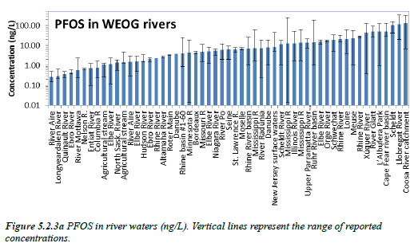
There are studies using plastic pellets as media for monitoring POPs level in the environment. See below an example of such data.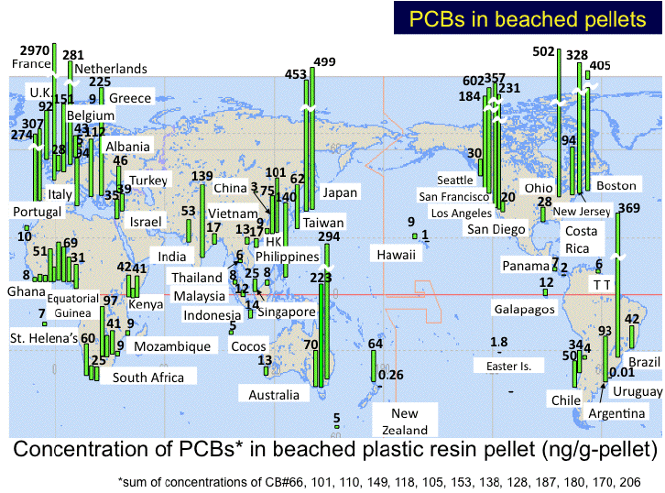
Source: http://www.pelletwatch.org/

